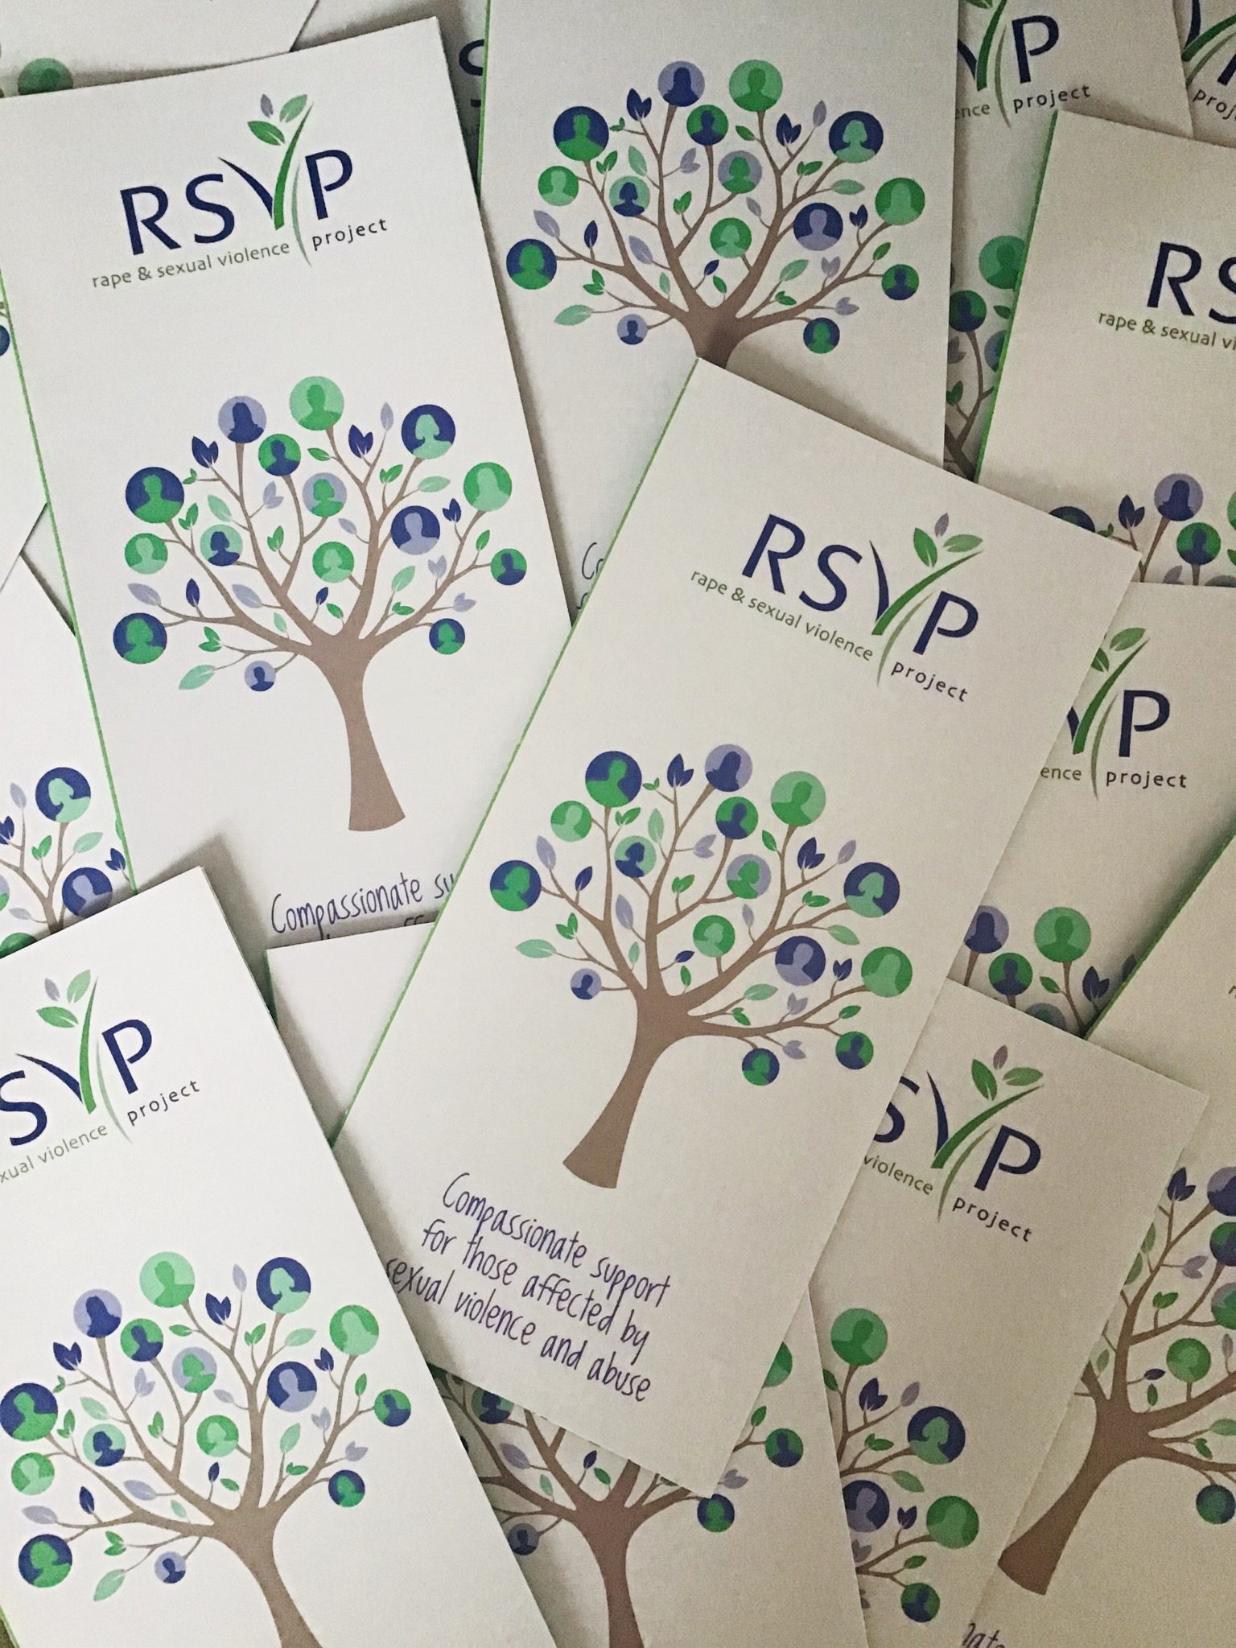



Applicant Information Pack
CYP ISVA. Part-time role, 22 hours.

- Person Specification
- Application Form
- How to apply
- Our Pledge to You
info@rsvporg.co.uk
www.rsvporg.co.uk
Services Line: 0121 643 0301
Helpline: 0121 643 4136
- Recruitment & Selection Statement
- Welcome Letter
- Our Mission, Vision & Values
- About RSVP
- Job Description
This pack includes:



info@rsvporg.co.uk
www.rsvporg.co.uk
Services Line: 0121 643 0301
Helpline: 0121 643 4136
RSVP is an award winning, long established and well respected specialist charity supporting children and adults of all genders following rape, sexual abuse and sexual exploitation. We are a vibrant, trauma-informed organisation. We believe survivors. We are bold and will go the extra mile to support survivors. We are big hearted, showing the empathy that survivors deserve and need. If you fit these values then we would love to hear from you!

RSVP is committed to equality and valuing diversity.

This includes a commitment within our recruitment and selection processes, where we are welcoming applications from across the community and are actively encouraging applicants with a protected characteristic to join our bold, believing & big-hearted team.

RSVP believes that survivor voice is vital and central to everything that we do.

We are committed to ensuring that individuals subjected to sexual violence and abuse are involved at every level of our organisation. Therefore, we welcome applications from individuals with lived experience of sexual trauma who also meet the person specification, so we can work together, engage and amplify survivors’ voices throughout all our work.

RSVP is committed to ensuring the safety of the individuals we support. More details can be found in our Adult & CYP Safeguarding policies (available upon request).

Recruitment & Selection Statement


a world free from sexual violence and abuse Charity Number 1134387
August.2026

Dear Applicant

Thank you for your interest in joining the Rape & Sexual Project (RSVP). I am pleased to enclose an Applicant Information Pack which includes further details.

Care in completing the Application Form will help us to give your application the consideration it deserves; naturally, this will be treated in the strictest confidence. Guidance Notes to help you complete the Application Form are included. Please also complete the Equal Opportunities Monitoring Form, along with your Application Form.

If you would like any further background information about our organisation and our work. Please visit www.rsvporg.co.uk. If you would like to discuss this position further, please contact me on yvonne@rsvporg.co.uk

Yours sincerely,

Yvonne Langham, Head of ISVA Services
Welcome Letter
PO Box 9558 Birmingham B4 7QE
t: 0121 643 0301
e: yvonne@rsvporg.co.uk
e: isva@rsvporg.co.uk
Values
Bold * Believing * Big-hearted
Mission, Vision & Values




Bold * Believing * Big-hearted
To support people who have been subjected to sexual violence and abuse to thrive and enjoy a future of hope and confidence.
We boldly stand with survivors and challenge victim-blaming attitudes.
Mission & Vision
We boldly stand with survivors of sexual violence & abuse through our actions, words & work
We believe survivors of sexual violence & abuse
We are big-hearted & approach our work with compassion
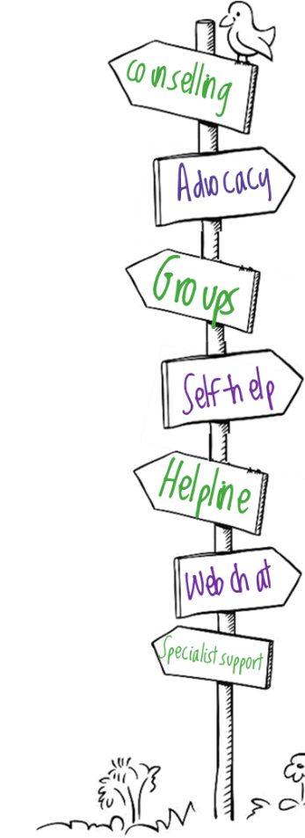
About
RSVP
We support people who have been subjected to sexual violence and abuse, in Birmingham and Solihull, to cope with trauma and rebuild wellbeing, confidence and hopefulness. Sexual violence and abuse can affect anyone and so we support survivors of any age, and any gender.
RSVP take a trauma-informed approach to services, we don’t label or judge, but listen, respect and support survivors to make their own decisions. We provide a broad range of innovative services, including counselling, advocacy, group support, self-help resources, helpline support and social activities. Specialist support is available to LGBT and asylum-seeking/refugee survivors.

Rape and sexual violence, childhood sexual abuse, exploitation, coercion, trafficking and modern slavery are a global epidemic. Approximately 97,000 adults are raped every year in England and Wales, and 1 in 20 children have been sexually abused. Only 15% of survivors report sexual violence and abuse to the police. Sexual violence can have a profound impact on health and wellbeing. It is crucial that survivors receive the compassionate support they need and deserve.


94%
67%
of adult ISVA clients reported feelings better informed about the criminal
justice process
of adult counselling clients reported increased ability to cope with the effects of trauma
of adult counselling clients reported improved wellbeing & confidence
of children said they know there is someone at RSVP they can talk to
64%
50%
“I am a functioning mother & wife again, I never thought I would feel normal again, but thanks to RSVP I have my life back”
“My counsellor was so easy to talk to & inspired confidence within me”
across all our services:
Last year over 7.000 people needed our support
Bold * Believing * Big-hearted
The RSVP team, trustees, staff & volunteers, bring a wealth of different skills & experience. What unites the team is shared values around believing survivors, challenging victim-blaming & working in a trauma-informed way.
Our Team
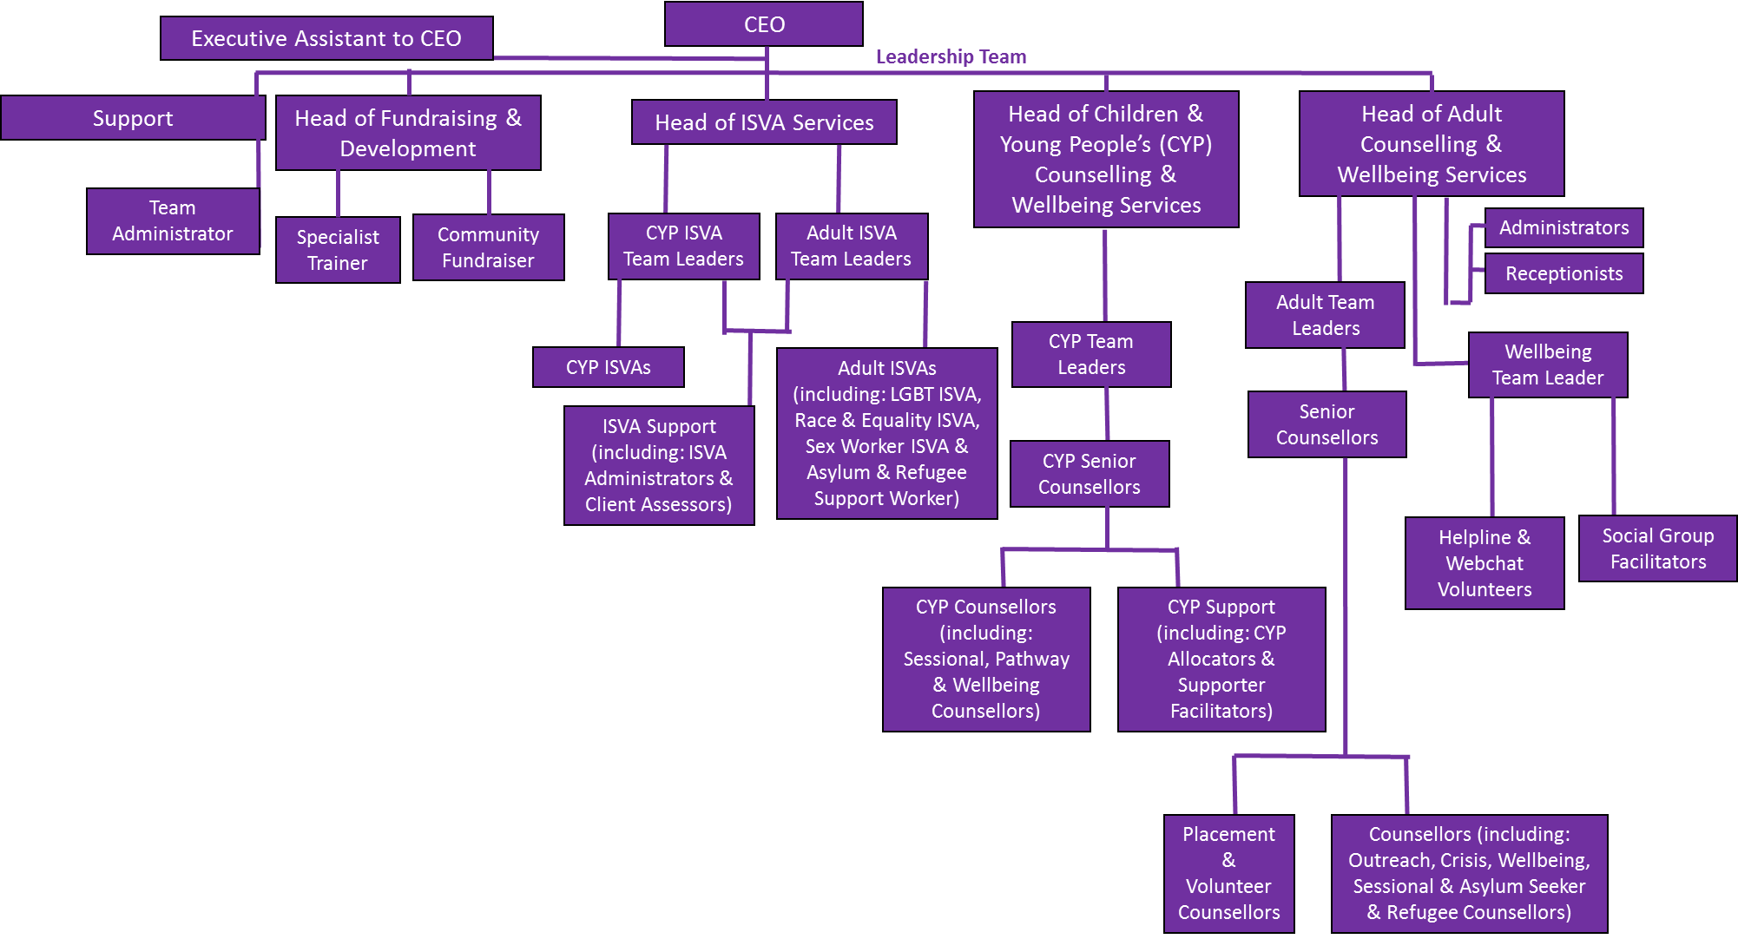
Our Team
Our RSVP Leadership Team consists of our CEO (supported by an Executive Assistant). Head of Fundraising & Partnerships (was Development), Head of ISVA Services, Head of Adult Counselling & Wellbeing Services and Head of Children & Young People’s Counselling & Wellbeing Services. Our Leadership Team is supported by various roles including Specialist Trainers, Team Administrator, Digital Fundraiser (was Community Fundraiser) and through admin support.

Our ISVA Team consist of Adult ISVAs (including Specialist ISVAs) and Children & Young People’s ISVAs, who are supported by ISVA admin roles & who work under ISVA Team Leaders, to provide advocacy support.

Our Adult Counsellors and Children & Young People’s Counsellors (including Specialist Counsellors, Volunteer & Placement Counsellors) & Counselling Support Roles work under Senior Counsellors, under Counselling Team Leaders to provide specialist counselling support.

Our Wider Services & Wellbeing Team consists of Helpline Volunteers (under a Team Leader), Webchat Supporters and Group Facilitators, under a Wellbeing Services Team Leader.

Bold * Believing * Big-hearted
Our trustees have experience and knowledge in data protection, safeguarding, risk management and social work.
Trustees
Counselling & Wellbeing Teams
Our adult Team Leaders and CYP Team Leaders support our Head of Adult Counselling & Wellbeing Services and Head of Children & Young People’s Counselling & Wellbeing Services to ensure the smooth running of services and to support the large team of staff and volunteers. Senior Counsellors assess new clients and allocate clients to counsellors, as well as providing counselling. Counsellors include qualified staff members, qualified volunteers and trainee counsellors (working towards qualification). Group Facilitators coordinate the wellbeing groups. Helpline/Webchat volunteers are trained to provide listening support and signpost to services.

ISVAs provide practical support, mostly through the criminal justice system but also with civil cases, with accessing health services (i.e. sexual health testing), and issues around employment, benefits and housing if those issues directly relate to the abuse a person has been subjected to. There are Adult ISVAs and Children’s ISVAs as well as specialist ISVAs.

To support frontline services and the stability of the organisation, we employ Administrators, a Fundraiser, Specialist Trainers, a Team Administrator and an Executive Assistant to our CEO.

ISVA Team




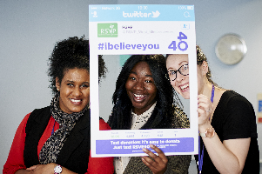

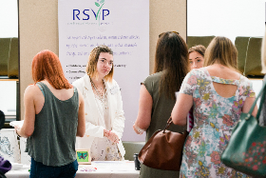

Bold * Believing * Big-hearted
Admin &Support Team













Bold * Believing * Big-hearted
Reducing pressures on the ISVA team. Covid has caused an enormous backlog within the criminal justice system; this means survivors are in limbo, not receiving decisions on their case for years sometimes. ISVAs are supporting too many people at one time, impacting the time they can give to any one person and the health and wellbeing of the team.
Increasing outreach support so services are available in different parts of Birmingham and Solihull. We want to offer people more choices around location.
Our Priorities
Collaborating with more community organisations so we are reaching the diverse population of Birmingham and Solihull and removing barriers to support.
Maintain and increase funding, including unrestricted income
Reducing waiting times for counselling. Adults and children are waiting far too long for their counselling to begin.
Challenging the criminal justice system, in light of record low conviction rates.
Our Pledge to You

We will continue to support our people & build a more supportive culture.
We want our team to continue feeling as though RSVP is a place where they can flourish, grow & develop in their role. We want our team to feel that there is space for us to reflect on & celebrate our work, & to connect with each other professionally, socially & humanely. We would like all our team to feedback that they experience RSVP as a safe & supportive space, organisation & employer. We want every member of our team to feel cared for & well-looked after, as we believe that every individual brings something unique to our organisation & that RSVP is nothing without our team & people.

We offer you:

Wellbeing support & resources
Our dedicated wellbeing platform (our RSVP Wellbeing Hub) is solely for you & your colleagues. The Wellbeing Hub features videos, written information & activities to support you with sleep, nutrition, self-care, stress, connection, boundaries, movement & much more! We also offer you access to specialist, external wellbeing resources, alongside ongoing internal wellbeing consultation.

You also have access to our BHSF App, with free EAP counselling, free legal, financial
& medical advice, financial discounts and more

Hybrid working
Many roles operate under a hybrid working model, with opportunities for remote working available.



Wellbeing &Social events
We offer wellbeing and social events for our team.
Updates
Regular Team Updates from our CEO with news, information & resources. You will also have access to Workplace which provides updates, resources & the opportunities for you to connect with your team.



Supervision
In accordance with your role, you will be offered regular work-based and/or clinical supervision, where you will be supported with your work.





Training opportunities & access to specialist resources
Previous training opportunities offered surround a trauma-informed approach, supporting women who engage in sex work & victim-blaming training.

our offer to you

Time off in lieu (TOIL)
When overtime is required & has been approved
Pension
3% pension contribution where applicable.
Awards & recognition
Our Trustees hold annual ‘Above & Beyond’ awards in which team members are nominated to receive the award and associated prize.
Annual leave
33 days annual leave, (inc. bank holidays) for full time staff, increasing with length of service, to a maximum of 39 days (inc. bank holidays) for 10+ years’ service.
Working practices
We also offer counselling roles with space in-between their counselling sessions for notes, admin & reflection.
Mileage allowance
. 45 p per mile

Bold * Believing * Big-hearted
Position: Children and Young People’s Independent Sexual Violence Advocate (CYP ISVA) Part-time 22 hours.
Summary & How the Role Makes a Difference

The CYP ISVA will work closely with but independently from the Police, Sexual Assault Referral Centre (SARC), Crown Prosecution Service (CPS), Witness Care, Birmingham Children’s Trust and other voluntary sector organisations etc. You will have experience and understanding of the traumatic effects and impacts of sexual violence, sexual abuse, sexual exploitation and sexual coercion and knowledge of criminal justice processes. Role is to advocate for and support CYP’s impacted by sexual violence.

Description / Contract
12 months contract. The contract could be extended however, this depends on RSVP securing future funding for the role.

Purpose of the post:

.To provide a high quality and victim/survivor-focused advocacy service to CYP who have been subjected to sexual violence, abuse, sexual exploitation and/or coercion, in order to:
· Provide emotional and practical support, at every stage of the victim/survivor journey
· Pro-actively and assertively advocate for those who have reported to the Police, are thinking of doing so, or choose not to report (safeguarding guidelines will be followed at all times).
· Ensure that the voices, needs, rights and legal entitlements of children and young people are heard, understood and acted upon by all individuals and organisations.
· Following safeguarding assessments and reduce risk to keep children and young people (and others) safe
· Ensure that victims/survivors can access the health and other support services that they need.
· Support the work of the CYP ISVA Team, and the wider ISVA Team (Adult, LGBT and Anti-Racism ISVAs) which may include working within Umbrella sexual health settings and other appropriate services as required.
· Work closely with our Counselling and Wellbeing Services Teams.

Salary

Untrained ISVA: £32,061 full-time equivalent NJC 19 plus 3% employer pension contribution (22 hours is £ 18,561.63)

Accredited ISVA: £33,699 full-time equivalent NJC 22 plus 3% employer pension contribution (22 hours pay is £19,509.95)

An approved and accredited ISVA qualification is preferable for this post, and will start at the accredited salary rate. However, candidates who demonstrate and live RSVP’s values (bold-believing-big hearted), and have a willingness to work towards ISVA accreditation will also be considered provided they have experience of working with children and those impacted by sexual violence.

Hours of work

Days/hours are Tuesday/Wednesday and Thursday. 9am to 3pm, 9am to 5pm and 11am to 7pm. The successful applicant will occasionally be required to work on a Saturday and Sunday.

Job Description
Bold * Believing * Big-hearted
Location
Job Description (continued)
Some hybrid after completion of induction, a minimum of 6 weeks into post.

Responsible to
Head of ISVA Services

Main Duties & Responsibilities (including responsibilities surrounding clients safe)

For all CYP clients
You will make contact with CYP referred to the CYP-ISVA service within 24 hours where possible, in order to offer support. (NB. For referrals made at weekends and out of hours this extends to 48 hours.)
Undertake safeguarding checks, risk assessment and support needs plan with CYP.
Consider child and adult safeguarding issues when engaging with CYP and follow relevant safeguarding policies and procedures.
Engage in morning briefing sessions as part of the wider CYP Team, to ensure you are fully informed of any CYPs who are currently at risk of CSE and actively engage in their agreed support plan.
Support CYP to make informed choices about their future options.
Develop individual service plan to address risks/support needs of CYP.
Help CYP to access services they need, and to which they are entitled, e.g. through setting up referral systems to health, sexual health, mental health and local counselling services etc.
Provide face to face, telephone, text and email based support to CYP, their families and wider supporters.
Help CYP develop a support network.
Explain criminal, legal and if relevant, civil remedies and housing options.
Where relevant and with client's consent and within data sharing protocols, keep other agencies informed about changes in CYP’s situation.

For CYPs Going Through Criminal Justice Processes
You will:
- Support CYP through reporting and at each stage of the criminal justice system, explaining the procedures and their legal entitlements and rights within the system.
- Support CYP in giving their witness statement and during the trial phase, in conjunction with Witness Services.
- Make urgent contact with CYP thinking of reporting to the police or SARC, so that if there is a need for forensic examination or support, all relevant early evidence can be captured.
- Provide information on Criminal Injuries Compensation
- Liaise with the police, CPS, Social Services, schools, colleges and other agencies on behalf of CYP, with the CYP’s consent and adhering to confidentiality and data sharing policies and procedures.
- Keep the CYP and their families and wider supporters informed about the progress of their case, in line with the requirements of the Victims Code of Practice.
- If the assault was DV related and the CYP is assessed as high risk, refer on to MARAC and an IDVA following locally agreed protocol. Attend and participate in meetings where required and follow-up on actions agreed in MARAC.
- Raise with police and/or local child services, any risks or safeguarding concerns around a vulnerable child at risk of any form of abuse.
- To participate in case conferences with the police, CPS, Social Workers and prosecuting barrister etc.
- To ensure CYPs impacted by CSE are proactively supported and safeguarded.
- To understand and communicate the needs of each CYP in relation to special measures, to ensure that they can access the support they require..

General:
- Maintain confidentiality..
- Manage a caseload.
- Maintain and monitor confidential notes and records.
- Act as a chaperone, going with survivors, to provide support and ensure that their voices are heard when they:
  - Give a statement to the police
  - Have evidence gathered by the police/SARC
  - Attend sexual health clinics for testing or treatment
  - Visit Court prior to a trial for familiarisation
  - Give their evidence in court, providing emotional support during this stressful time
- Follow procedures, policies and protocols with other services so that the safety of the CYP survivor is kept central at all times.
- Note and feed back to other agencies any consistent difficulties survivors are having accessing their service.
- Contribute to the development of service policies, protocols, guidelines and strategies within area of practice as necessary.
- To develop and maintain effective communication systems with key partners including the police, CPS, court services, employers, colleges, mental health and sexual health services, Victim Support, Witness Service, Birmingham Children’s Trust and voluntary sector organisations.
- To participate in team meetings.
- To provide specialist advice to other workers and agencies, including participation in delivery of training sessions.
- To have a clear understanding of the:
  - Myths and facts of sexual violence and abuse, and the impact this has on CYP’s.
  - Coping strategies and impacts of sexual violence and abuse to survivors and their families.
  - Long term emotional, and physical health effects of sexual violence and abuse
  - Risks that adults and CYP are exposed to.
- To be aware of how to access resources available, regarding interpreters, signers, etc.
- To monitor and evaluate the effectiveness of RSVP CYP-ISVA service.
- To be familiar with all aspects of the work of RSVP and Umbrella sexual health Services.
- Work flexibly as a member of the team and be responsive to changing needs.
- Be willing to undertake relevant training as required.
- Work within the policies and procedures of RSVP and demonstrate a commitment to their values, principles and ethos.
- Undertake any other duties that fall within the nature of the role and responsibilities of the post holder.

{This role is subject to an enhanced DBS check - application to DBS will only be submitted if offered the position}
Person Specification
Essential / Desirable  Any offers of appointment will be conditional on staff committing to completing training in those areas deemed essential to the post | Method of  Assessment
 | A | I | E
Essential
Qualifications and Training
Good standard of education (Level 4) or equivalent experience | X | X
Employment History
Previous or current experience within a specialist rape and sexual abuse organisation, supporting adult victims/survivors of sexual violence and abuse. | X | X
Previous or current experience supporting adult victims/survivors of sexual violence and abuse, and their partners, families and wider supporters | X | X
Good knowledge and understanding of the nature and impacts of sexual violence and abuse | X | X
Experience of working pro-actively, and advocating for adult survivor voices and needs | X | X
Excellent listening skills | X | X
High standards of practice and presentation of work | X |  | X
Able to prioritise own workload and deal with competing demands |  | X | X
Experience of working with a range of agencies | X | X | X
Extensive knowledge of adult safeguarding issues, legislation and best practice | X | X | X
Understanding of the need and ability to maintain professional notes and records of their interactions and interventions with clients | X | X
Proficient with IT, with experience of working with Microsoft Excel, Microsoft Word and Outlook. | X | X

(This form indicates how the requirements will be assessed during the selection process).

A - Application form I - Interview E – Exercise
Personal Attributes
Commitment to RSVP’s values: BOLD, BELIEVING AND BIG-HEARTED | X | X
Ability to work on own initiative, in partnership and as part of a team | X | X
Ability to produce well written letters, responses and reports | X | X
Knowledge of and commitment to diversity, equal opportunities and anti-discriminatory practice | X | X | X
Strong crisis management skills | X | X | X
Ability to work in an empathic manner and develop a safe supportive relationship, rapport and alliance with clients | X | X

Desirable

Completed accredited ISVA training course | X | X
Special Requirements:
Eligible to work in the UK | X
An Enhanced DBS check- we will carry out our own check |  | X
Willingness to access training relating to duties, especially ISVA specific training | X | X
Able to work unsociable hours and to travel as required |  | X

Bold * Believing * Big-hearted
Guidance Notes:
Completing Your Application Form

Thank you for considering this opportunity with RSVP. These notes are meant to help you decide if you want to apply and to improve your chances of being invited for an interview.

Please read ALL the information contained within this pack before you fill in the form.

The Job Description tells you the work you will do if you are appointed.

The Person Specification is very important. It tells you what skills, knowledge and experience you will need to be able to do the job.

Decisions on who to invite for interview are based on what you put on your Application Form - make sure you show how (with examples) you meet each of the criteria identified in the Person Specification.

DON'T FORGET that where you are asked for details of relevant experience, it doesn't just mean paid work. You can back up your statements with examples of what you have done in the past either at home, school or college, in paid work or unpaid work, or as a hobby. For example:-

- Running a home may involve a range of skills like organising and budgeting;
- Being active in a club, tenant's group or other voluntary organisation may show skills like teamwork, communicating or service delivery.

GENTLE REMINDERS:
- Use the application form - we will not consider CVs, resumes, etc.
- Use continuation sheets if you need to - but make sure they have your name on
- Make sure you show how you meet all the criteria in the Person Specification.
- Please remember to complete the Equal Opportunities Monitoring Form since this information helps us to check that everyone is being treated fairly.
- Please make sure that your Application Form is returned in good time for the closing date since forms received after the closing date cannot normally be considered.
- If your application is unsuccessful you can always request feedback by telephoning or writing and please do not be discouraged from applying for other vacancies.

Once again, thank you for your interest and good luck with your application.

Bold * Believing * Big-hearted
Surname: Click or tap here to enter text. | Forename(s) : Click or tap here to enter text.
Any former names: Click or tap here to enter text.
Home Address:
Click or tap here to enter text.
Postcode:
Click or tap here to enter text.

E-mail Address: Click or tap here to enter text. | Home / Mobile Tel No: Click or tap here to enter text.
NI number: Click or tap here to enter text. | Work Tel No: Click or tap here to enter text.
Are you related to anyone at RSVP?  ☐ Yes ☐ No  If yes, please give details  Click or tap here to enter text. | In order that RSVP may consider reasonable adjustments, are you a disabled person, as defined by the Equality Act 2010 (I.e. do you have a physical or mental impairment which has a substantial and long term adverse effect on your ability to carry out day to day activities)?  ☐ Yes ☐ No
I order that RSVP can fully consider any reasonable adjustment required to enable a disabled person to carry out the duties of a post please:

- give details of any adjustment you may need to help you carry out the duties of the post applied for
Click or tap here to enter text.

- give details of any special arrangements you will need (e.g. wheelchair access, sign language interpreter) if invited for interview.
Click or tap here to enter text.

Please note, a disability or health problem does not preclude full consideration for the job, and applications from all suitable applicants are welcome. All information provided by applicants will be treated as confidential.
Application Form
Personal Information
Present and Previous Employment
Application Form

What is your present job title?  Click or tap here to enter text. |  |  | Duration employed in this position (years/months)  Click or tap here to enter text.
Name and address of employer  Click or tap here to enter text. |  |  | Current salary/grade  Click or tap here to enter text.
Nature of business
Click or tap here to enter text.
Notice required
Click or tap here to enter text.
Please describe your role in the organisation and outline your responsibilities
Click or tap here to enter text.

Please list your previous appointments with the most recent first (please include details for any long periods of unemployment)
Name and address of employer: | Position held: | Employment start date & end date: |  | Reason(s) for leaving:
Click or tap here to enter text. | Click or tap here to enter text. | Start date:Click or tap here to enter text. End date:Click or tap here to enter text. |  | Click or tap here to enter text.
Click or tap here to enter text. | Click or tap here to enter text. | Start date:Click or tap here to enter text. End date:Click or tap here to enter text. |  | Click or tap here to enter text.
Click or tap here to enter text. | Click or tap here to enter text. | Start date:Click or tap here to enter text. End date:Click or tap here to enter text. |  | Click or tap here to enter text.
Click or tap here to enter text. | Click or tap here to enter text. | Start date:Click or tap here to enter text. End date:Click or tap here to enter text. |  | Click or tap here to enter text.
Please continue on a separate Word Document (or on an additional sheet at the end of this Application Information Pack if needed), with clear indication of the question/section being answered.
Secondary School(s) | Qualifications gained (with grades attained)
Click or tap here to enter text. | Click or tap here to enter text.
College/University/correspondence course (state if full or part time)  Click or tap here to enter text. | Qualifications gained (with grades attained)  Click or tap here to enter text.
Name and type of membership of professional body
Click or tap here to enter text.

Job related training courses attended & dates of award/qualification/certification attained

Click or tap here to enter text.

Education
Application Form

Training

Please continue on a separate Word Document (or on an additional sheet at the end of this Application Information Pack if needed), with clear indication of the question/section being answered.
This section of the Application Form is for you to demonstrate how you meet the requirements of the Person Specification and to explain why you are applying for the job. You must ensure that you show that you meet all of the Criteria from the Person Specification.

Click or tap here to enter text.

Experience
Application Form

Please continue on a separate Word Document (or on an additional sheet at the end of this Application Information Pack if needed), with clear indication of the question/section being answered.
We require candidates to provide details of two referees and preferably both should be qualified to comment on your work performance in the last 3 years, particularly in relation to the person specification/competencies required.

One of your referees must be your present or last employer. We will not contact your present employer prior to an offer of appointment without your permission. If you have not previously been employed then Head Teachers / College Lecturers etc are acceptable as referees. Friends and relatives are not acceptable referees.

In addition the Rape & Sexual Violence Project reserves the right to approach any other previous employer or manager.

References will be taken up for the appointable candidate once an offer of employment has been made; therefore, you should ensure that your referees are in a position to respond promptly.

If you were known to your referee by a different name, please indicate your previous name.

All appointments are subject to satisfactory references. The Rape & Sexual Violence Project reserve the right to terminate any offer of employment or employment contract if the references prove to by unsatisfactory.

A. Click or tap here to enter text. | B. Click or tap here to enter text.
If your present employer is not named as a referee, do you have any objections to their being asked for a reference?  ☐ Yes ☐ No | More information on how we request references can be found in our Recruitment Policy (available upon request).
Referees
Application Form
Declaration
Application Form

Where did you hear about this role? (please tick all relevant answers)
☐ BVSC | ☐ The Survivors Trust | ☐ From an existing RSVP team member
☐ Indeed | ☐ Word of Mouth | ☐ Charity Jobs
☐ Another organisation (please specify):  Click or tap here to enter text. | ☐ Social media (please specify):  Click or tap here to enter text. | ☐ Other (please specify):  Click or tap here to enter text.

Self-disclosure form: criminal history
We invite you to disclose any criminal records, pending criminal proceedings or suspended sentences here:
Click or tap here to enter text.

Disclosure and Barring Service (DBS)

All individuals working at RSVP, on a paid or voluntary basis, will undergo a DBS check of criminal records. This check must be completed before your work at RSVP commences. RSVP will always complete our own DBS check, regardless of checks that have been made by other organisations. These checks will be updated every three years and staff are to disclose to their line manager or Designated Safeguarding Lead any information which may subsequently show up on DBS checks once employment has commenced. Staff must also disclose if they are living in the same household where another person who is disqualified lives or is disqualified ‘by association’ as specified in regulation 9 of the Childcare (Disqualification)Regulations 2009 as made under section 75 of the Childcare Act.

I declare that, to the best of my knowledge and belief, all statements contained in this form are correct. I understand that should I conceal any material fact, I will, if engaged, be liable to the termination of my contract of employment.
Providing false info is an offence and could result in the application being rejected or summary dismissal (and possible police referral) if your application is successful.

Signed:  Click or tap here to enter text. | Date:  Click or tap here to enter text.

All information contained in the Application Form will be processed in accordance with our Data Protection Policy.
Application Form

Additional Sheet
Section/Question: | Continuation of answer:
Click or tap here to enter text. | Click or tap here to enter text.

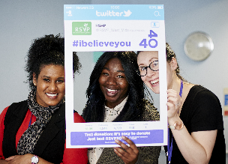






If you would like any other background information about our organisation and our work, please visit www.rsvporg.co.uk
If you would to discuss this position further, please contact:
Head of ISVA Services, Yvonne Langham on 07534480173

Please email this Applicant Information Pack (containing a completed Equal Opportunities Form & Application Form)
To yvonne@rsvporg.co.uk by:
5pm on Friday 30th Sept 2026 at the latest.
This Advert may be closed early, should the right candidate apply.

Interviews will be held early Oct 2026 Dates to be confirmed.


for taking the time to work through this Applicant Information Pack. We’re excited to receive your application.
Services Line: 0121 643 0301
Helpline: 0121 643 4136
info@rsvporg.co.uk
www.rsvporg.co.uk
How to Apply







Bold * Believing * Big-hearted
@RSVP_West_Mids | @RSVPWM
rsvporg.co.uk | 0121 643 0301 | info@rsvporg.co.uk
info@rsvporg.co.uk
www.rsvporg.co.uk
Services Line: 0121 643 0301
Helpline: 0121 643 4136

