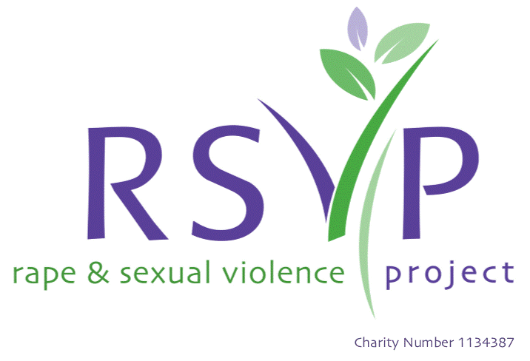
For Office Use Only:

Client CIVI Reference:
Name of Team Member Receiving this Form:
Date Received:
Request for Support Form

Hello. Thank you for contacting RSVP for support – we know this takes courage & our bold, believing, big-hearted team are for you every step of the way. This form is designed to collect information to find out what support you need & will allow us to start the process of offering you support as quickly as possible. Please note, we are only able to support individuals in Birmingham & Solihull. We are unable to support adults who have sexually harmed. All information you provide is kept secure & confidential.

Service/(s) & Support Desired
Please complete all fields/info (or indicate if you do wish to answer)
Please indicate by marking an ‘X’ next to boxes.
‘………’ indicates that you can write your answer in this space.

☐ Adult counselling
If ‘YES’, please select a preferred location for counselling (adults only).
*Our Birmingham City Centre location offers counselling from Monday to Sunday, while counselling availability from other locations is subject to limited days/times. While we are unable to always meet your preferences, we will try to accommodate where possible.
Locations: telephone, online, Birmingham City Centre (in-person), Solihull (in-person), Castle Vale (in-person), Chelmsley Wood (in-person), Erdington (in-person), Kings Heath (in-person), Sutton Coldfield (in-person)

Preferred location 1: ……… Preferred location 2: ……….

Please note, immediate specialist counselling (paid for private counselling with no waiting lists) for individuals subjected to sexual violence & abuse is available via our sister organisation, GINA.

We are able to support you with Advocacy services regardless of whether you have reported an offence or not. If you would like to access any advocacy support in relation to a sexual offence reported to the police, please complete the ‘For Advocacy Services Surrounding a Reported Sexual Offence Only’ section on the last page of this referral form.

☐ Adult Advocacy (ISVA service)

☐ LGBT Advocacy (ISVA service)

☐ Sex Worker Advocacy (ISVA service)

☐ Arts with Hearts (arts & crafts group)

☐ Social Groups (women’s day group, women’s evening group, Chinese women’s group, young women’s group, mixed gender group, female asylum & refugee group)
Social group/(s) interested in:…………

☐ Pre-Therapy Group - trauma-informed group support for females 18+ who have been subjected to sexual violence & abuse.

☐ Coffee Mornings

☐ Self-Help Resources
(please note, our sister organisation, GINA, also offers a range of free bespoke resources for individuals subjected to sexual violence & abuse).
If you require paper copies of any of our self-help resources or leaflets posted to you, please drop us an email to info@rsvporg.co.uk.
☐ Online Support (Taste of Recovery & MindBody)

☐ Specialist Counselling for Refugee & Asylum Seeker Survivors
☐ Specialist Social Group for Female Refugee & Asylum Seeker Survivors
☐ Specialist Support Work for Refugee & Asylum Seeker Survivors
☐ Children & Young Person’s Counselling
☐ Children & Young Person’s Advocacy (ISVA service)
☐ Supporters Circle – support for parents/carers supporting a child or young person subjected to sexual violence & abuse
☐ Supporters Programme - support for parents/carers supporting a child or young person subjected to sexual violence & abuse

Referrer
☐ Self-referral OR
☐ Referral from another organisation (e.g. School, GP)

Where did you hear about RSVP?:…………………………………
Name of agency: ………………… Contact number: …………..
Name of referrer: ………………… Email Address: ……………
☐ General enquiry about RSVP ☐ Enquiry on behalf of client

Details of the individual accessing support
Please tick all that apply:
☐ I have been subjected to sexual violence & abuse
☐ I am supporting someone who has been subjected to sexual violence & abuse

Name: …………………
Date of birth:…………………………..
How would you describe your gender? ……………………
(i.e. female, male, non-binary, transgender female, transgender male, prefer to self-describe, prefer not to say)
(if prefer to ‘self-describe’, we invite you to do so here):…………………….
How would you describe your sexual orientation? …………………….
(i.e. heterosexual, homosexual, lesbian, gay, bisexual, queer, questioning, prefer to self-describe, prefer not to say)
(if prefer to ‘self-describe’, we invite you to do so here):……………………….
What is your preferred method of contact? ……………………………..
(i.e. by phone, by email, by post, by phone or email, no preference)
Address (we are only able to support individuals in Birmingham & Solihull): ……………………
Is this a safe address where we can write to you? (i.e. yes, no, n/a)…………………

For Under 18s: Contact details for individual with parental responsibility:
Name: …………….. Email: ……………….
Contact number: …………….. Address: ………………….

A safe contact number to reach you on: …………………………………….
(please note, we may be calling from a withheld number)
A safe contact number to reach the child or young person on (if different): ……………………………………….
Is it safe to leave a message? (i.e. yes, no, n/a) ……………………….. Is it ok to send text messages? (i.e. yes, no, n/a)……………………………......
Are there any special instructions regarding phone calls and messages? (if so, please detail): …………………………………….
A safe email address: …………………………………………….
Is it ok to send emails? (i.e. yes, no, n/a) ………………………………….. Please check your spam/junk folders

We ask the following questions to help make sure RSVP is reaching everyone who needs support.
How would you describe your ethnicity?
☐ Asian or Asian British: ………………………….
(i.e. Asian, Asian British, Indian, Pakistani, Bangladeshi, Chinese, Any Other Asian Background)
If ‘any other Asian background’, please describe: ……………………..
☐ Black, Black British, Caribbean or African: ………………………….
(i.e. Black, Black British, Caribbean, African, Any Other Black, Black British or Caribbean Background)
If ‘any other Black, Black British, Caribbean or African background’, please describe: ……………………..
☐ Mixed or Multiple Ethnic Groups: ………………………….
(i.e. White & Black Caribbean, White & Black African, White & Asian, Any Other Mixed or Multiple Ethnic Background)
If ‘any other Mixed or Multiple Ethnic background’, please describe: ……………………..
☐ White: ………………………….
(i.e. English, Welsh, Scottish, Northern Irish, British, Irish, Gypsy or Irish Traveller, Roma, Any Other White Background)
If ‘any other White background’, please describe: ……………………..
☐ Other Ethnic Group: If ‘any other Ethnic Group’, please describe: ……………………..
(i.e. Arab, Any Other Ethnic Group)

What is your primary language? ……………………………….
Do you require an interpreter? (i.e. yes, no, n/a) ..................................
If so, which language do you require? ……………………

Do you consider yourself to have a disability? (.ie. yes, no, prefer not to say) …………………………………………………….
If so, please detail: …………………………………………………..
Please detail any support needs (signer, hearing loop): ……………………………………………

re you neuro-divergent? (i.e. yes, no, prefer not to say) If so, please describe: ……………………………………………………
Please detail any support needs: ………………………………………………………………………………

Do you consider yourself to have any mental health difficulties (e.g. depression, anxiety, eating difficulties…)?
(i.e. yes, no, prefer not to say) If so, please describe:………………………………………………………….
Please detail any support needs: ………………………………………………………………

Reason for accessing our support: how would you describe what you have been subjected to?
Please mark an ‘X’ next to all that apply
We support individuals subjected to sexual violence & abuse.
We do not support adults who have sexually harmed and/or are a risk to others.
☐Sexual abuse in adulthood
☐Sexual abuse in childhood
☐Sexual abuse in adulthood & childhood
☐I am a supporter
☐Rape
☐Sexual assault/sexual violence
☐Child sexual exploitation
☐Adult sexual exploitation
☐Satanic/ritual abuse
☐Domestic abuse
☐Forced prostitution
☐Trafficking
☐Forced marriage & honour-based violence
☐Sexual harassment
☐Online sexual abuse (e.g. Image-based abuse (intimate images shared without consent), ‘sexting’, ‘revenge porn’)
☐I don’t know how to describe it
☐Prefer to chat it through with someone from RSVP
☐Other:………………………………….

Do you have anything else you’d like to tell us? Is there any more info/details you feel are important to share? Do you have any questions, queries or worries you’d like to explore with us?
…………………………………………..

To be completed by police officer (or any individual holding some or all of this info): For Advocacy Services Surrounding a Reported Sexual Offence ONLY
Please ONLY complete this section if you/they have reported a sexual offence to police & you/they would like Advocacy support through reporting, court and the criminal justice process. Please also please complete if the individual is a child or young person under 18yrs.
Type of offence reported: …………………
Date offence reported:……………………..
Brief details: ……………………………..
Name of perpetrator/(s): …………………
Relationship (if any) to perpetrator/(s): …………………..
Gender of perpetrator/(s): …………………
When did the offence take place? ………………………….
Where did the offence take place?
☐ Birmingham & Solihull ☐ Other: ………………………………….
Have you attended a Sexual Assault Referral Centre (e.g. Horizon)? ☐ Yes ☐ No
Name of police officer dealing with the case:
………………………….. Police station: …………………….
Police tel. number: ……… Police officer email: ……………………….
Crime number (if known):…………………………….
URN number (if known): ………………………………
Sent to MARAC (Multi-Agency Risk Assessment Conference)?
☐ Yes ☐ No ☐ Unknown
Progress with the case so far (e.g. awaiting trial/court date): ………………………………………
Is the client pregnant? ☐ Yes ☐ No
If ‘yes,’ what is the due date: …………………………………..

Thank you for your referral – we will be in touch soon.
To support us in keeping your information secure, we recommend you password protect this document before returning it to info@rsvporg.co.uk. Please send your password to us in a separate email.
☐ I consent to this referral/I can confirm that the individual I am referring has consented.
☐ I confirm that I have completed this form with as much information as I feel able to offer.
☐ I give consent for RSVP to securely store my confidential data in accordance with GDPR guidelines.

Our service is confidential and we will never share personal contact details or other sensitive information unless we are required to do so in the interests of safeguarding or by law. The information you provide on this form will be used to help us understand if we are reaching all parts of our community and help us to develop our services.

